24-03-2020

Team LOCALHOST

Agile systems

AR-VR PAAS

**AR – VR PaaS**

**Team LOCALHOST**

GitHub: <https://github.com/adityakumaar/Agile-AR-VR-PaaS>

**SUBMITTED TO:**

**Dr. DURGANSH SHARMA**

**Assistant Professor (SS) Department Of Computer Application**

**Group Members:**

|  |  |  |  |
| --- | --- | --- | --- |
| **NAME** | **SAP ID** | **GitHub** | **ROLL NO.** |
| **Aditya Kumar** | **500066319** | **adityakumaar** | **04** |
| **Anuj Verma** | **500066910** | **anujverma28** | **09** |
| **Dhananjai Kalra** | **500070904** | **dhananjaikalra28** | **14** |
| **Mayank Joshi** | **500070105** | **199lucy** | **25** |

Contents

1. ABSTRACT 3

2. Introduction 4

2.1. Manifestos for Agile Software Development 5

3. Methodology 6

3.1 WHY CLOUD? 6

3.2 WHAT IS OUR PLATFORM? 7

3.3 METHOD USED 9

3.4 REQUIREMENTS 10

3.5 STATISTICAL ANALYSIS 11

3.6 TARGET AUDIENCE 12

4. Data flow diagram (DFD) 13

5. Entity Relationship Diagram (ERD) 15

6. Program Evaluation and Review Technique 16

7. CONCLUSION 17

8. REFRENCES 17

# ABSTRACT

AR and VR technologies use high-end graphics and processing in order to work, which ultimately require high performance machines that are quite expensive. So if a person wants to utilize this technology, they will have to shell out a significant amount of money just on the machine itself which is not very cost effective. As rapid technological changes have become a general scenario today, purchasing such machines which support AR-VR can be categorized into an inefficient investment.

The best example for the above-mentioned problem can be taken of a freelance developer. A freelance developer may have a project that requires the use of AR or VR once in a while. Also for one project he may require a comparatively simpler machine and for other he may require a whole set of advanced configurations. Thus, making the job of data gathering and updating, expensive as well as tedious. In such scenario, upgrading his machine will constantly require to stress out a lot of money which may lead to financial troubles. Also, these machines are not exactly user friendly when it comes portability. Therefore, the best possible way to counter such limitations is to bring the facility of AR-VR to users with the help of online platforms. They are cheap, easily accessible and can bend to the users will. They can provide the same facilities to all users on any device using cloud services.

Another example can be taken of a university where they might require machines for every student for AR or VR technology-based learning/creation. To fulfil those needs they will have to constantly upgrade their hardware as per the growing requirements and all the hardware will also be requiring maintenance which leads to high costs.

Our product aims to provide AR-VR Platforms as a Service to people/organizations, where anyone can use our cloud platform as per their requirements. Our platform will give them capabilities to render anything and everything on cloud using our servers. All the services provided will use basic configuration machines and generate high quality content which otherwise would not be possible with a low-end system.

This platform will be used on commercial basis. Users will be able to get access to our service on pay per day basis or a long-term plan. Our platform will also provide the feature/capability of scalability which will allow them to upgrade or downgrade their cloud machine capabilities/performance as per their current needs allowing them to pay only for what they use rather than paying for a high performance machine all at once which may or may not be of their use later on.

# INTRODUCTION

The field of software development and management has significantly grown in the past ten years. At a point in time, the basic need of common populous was to just sort out their grocery lists, but today, computers and software in itself has become a major part of everyone’s day to day life. Innovations and changes in computer software are a very common occurrence in this time. This is all because the users around the globe today are driven by the zeal of living life virtually than in reality. As such, the concept of **augmented reality** and **virtual reality** has become a booming market today.

This project is based on latest and emerging technologies of **Augmented Reality and Virtual Reality**. The main purpose of AR-VR is to provide consumers with a sense of living a limitless virtual life, which is free of any obligations. Following this idea, and the principles and values of agile manifestos, we are developing a **Platform as a Service** for the users who want to create their own Augmented Reality and Virtual Reality content. The services provided in this platform will target every user on any device, unbiased towards the hardware requirement. The main idea is to generalize AR-VR creation to all the users that need it, without constructing any hardware limitations.

Even though this technology itself is not complex in nature, the use of AR-VR is confined to a small group of people. This limitation is as such because of the high configuration it demands from the hardware and network. The maneuverability of this technology highly depends upon the hardware and software it is running on.

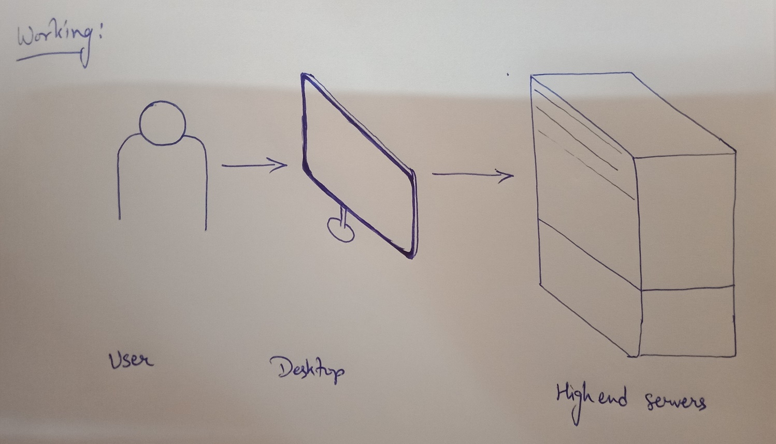

Our platform will eliminate this limitation to the best possible extent and provide users with the same services, unbiased towards the network or hardware they are using. Creation, modification, save and download are the four main services we will provide on this platform. This platform will cater to all the needs of the user in generating AR and VR content. The software will run on our cloud servers and an instance of the process will be displayed on the user’s desktop.

Additional services provided on this platform might also include a marketplace for selling and buying the AR and VR content, creating a community in itself. We aim to create this platform very user friendly, so that users can access, modify and create whatever they want without restrictions. All of the processes from creation to modification will be contemplated in real time. The users will also be given options to download their creation on their systems or save them on the cloud for further alterations.

Concerning the financial factors, this platform will be made accessible to public on a subscription basis only. The platform will be developed exactly according to the needs of the customers.

## Manifestos for Agile Software Development

The agile manifestos include four of the most important values for the development and regulation of customer satisfaction. It also ensures flexibility towards changes throughout the phase of development. Our software follows all the values and principles as per listed under agile manifestos and ensures optimal quality of service towards the customers whilst non-compromising the integrity of the developer as well as the software.

* + - **Individuals and interactions** **over processes and tools**: The AR-VR PaaS strictly follows one agenda, i.e. providing AR-VR services to every consumer without biasness towards hardware. All the processes and tools used in the development are regulated optimally, keeping in mind the needs of the consumer base.
    - **Working software** **over comprehensive documentation**: Practicality is one of the foremost module of this project. Providing consumers with a service to model their imagination is our main goal. Agile manifestos lean towards forming a working software more than documentation. Even though documentation is a tedious task, we strive in creating a balance between every phase of development. From documentation to the working model each and every task is taken care optimally without hindering the other.
    - **Customer collaboration** **over contract negotiation**: Customer collaboration is a must in developing the most efficient software. Our platform will directly interact with the consumers at every point of working and keep them updated on development of the product, as well as the working of every phase.
    - **Responding to change** **over following a plan**: A customer is very prone to change his/her ideas in the midst of development phase. Our platform supports as well as encourages the consumers to flow their ideas freely. The development will always be in close collaboration with the consumer and will always be flexible towards changes.

# METHADOLOGY

Earlier in the 1990’s, when world was still adapting to computers, some few geniuses and other nerds came with the concept of Augmented Reality. A revolutionizing concept. For people who dreamed in living the matrix itself, AR opened a whole new world. Later, when VR touched the ground, opportunities grew up even more. Creation and manipulation had a whole new definition now. With the help of computers and AR-VR technologies, people no longer had to cap their imagination. But there was one little problem, i.e. these technologies require the highest quality hardware to run effectively. And the worst part is, twenty years down the road and we still suffer with the same problem.

AR-VR surely is a fascinating field to be a part of, but its high-end requirements of hardware make it excessively expensive and, in some cases, inaccessible. In regards to this flaw, our team is creating an AR-VR platform where users will be entertained online using cloud services. The platform aims at bringing its users the best services of AR-VR whilst using cloud-based servers. This online platforms’ main purpose is to eliminate that ever existent flaw of excessive high requirements of hardware for AR-VR by shifting it all on cloud servers.

### 3.1 WHY CLOUD?

The use and need of cloud computing are increasing every day and cloud computing have certain cost and hardware benefits over building an equally powerful machine at client-side. And by our service we want to provide the users with a service which they can afford at minimal price and access over different platforms. The same platform will also provide the users with a marketplace where they can trade their AR/VR/MR content with other organizations and companies.

**Pros of using Cloud Servers over building a high-end computer at home:**

1. No need for onsite hardware or great capital expenses. Using a cloud server is well suited to small companies and individual users/creators because they may soon outgrow their storage needs and expanding storage on cloud is easy.
2. The cloud solutions are generally on demand so the users only have to pay for what they need.
3. Easy backup and restore facilities and access on multiple devices. Cloud services support automatic backup which can minimize data loss.
4. Automatic software and applications updates/upgrades.
5. Enhanced collaborations, cloud services can be accessed on multiple devices therefore, increasing the development collaborations.

**How will the user get benefits from using this cloud service?**

1. This will be a cross-platform service, which means it will be OS independent. Therefore, the user need not worry about setting up the service for different OSs.
2. Expandable hardware supports. The user can increase or decrease hardware resources as per their need and just pay for what they are using.
3. Automatic software updates and hardware upgrades. The users need not worry about their software and hardware upgrades as it will be automatically done at the server side.
4. The users can collaborate with their teams and other organizations as it is a cross-platform service.
5. The users can easily trade their applications and contents using the marketplace.

### 3.2 WHAT IS OUR PLATFORM?

Currently, the conventional way to create AR/VR/MR content is to purchase or rent a very high-performance machine that has high graphical and processing capabilities. This leads to problems of maintenance, scalability and upgradation. Carrying out any of these processes is time consuming, as well as expensive. So as to deal with this problem, our team is creating an online platform which will allow users to create their own AR-VR content

Details are mentioned below-:

1. We plan to provide users with a platform that can be accessed using a customised app or directly through browser.

2. On login, this platform will allow them to create their respective content all on cloud. All the graphical processing will occur on our high-performance machines/servers.

3. The user will use the default/predefined packages by simply dragging and dropping it onto the canvas/interface (it will be fully customisable according to user needs) or by creating their own modules. 4. The user modules can be created by them by providing all the necessary information such as dimension, colour, etc. along with photographs or vector diagrams, which on successful creation can be used to create their content.

5. The user only needs to sign up to our service in order to access it.

6. The platform will also feature a marketplace that will be used to share, sell, buy various modules and content created by different users of the platform allowing them to explore and share their ideas with the world. This will also open a lot of opportunities for people in content creation profession.

Augmented Reality

For AR content the process will be more like video conferencing, the user will point the camera in the direction he/she needs the AR content. The video will be sent to servers, users will customise the content on platform with live video in real time with all the rendering being done on the servers and the output video will be sent to the user device. This whole process will work in real time with least lag possible. The only requirement from the customer side to achieve the best possible result with least lag will be of high-speed internet connectivity with very low latency.

Virtual Reality

For VR content the user will need to provide the details of the environment such as dimensions, colour, objects in the scene, their placement etc., the object and environment can also be provided using suitable pictures clicked through various angles required which all will be processed, rendered and put together on the cloud and user will receive the final outcome as an interactive video on their device which will react on the basis of input provided by the user manually or through the input received by the sensors in user device.

Mixed Reality

For MR content somewhat a mixture of both the above processes will be used that will depend on the requirements of the user and the content will be produced accordingly.

Currently various institutions don’t use AR/VR/MR technologies due to high costs involved and also due to constant changes technology every day. As a solution to this problem, we have decided that access to our platform will be granted on a subscription basis with multiple users. A leased line to our servers will be used for highest performance possible and to be able to handle large loads as a lot of simultaneous users will use the service. We will recommend high performance Wi-Fi routers and antennas at the client end for them to be able to use the service at its full potential with zero performance drop. By doing all this, our compliant will have the option of scalability allowing them to handle as many users required without having to waste time in setting up the new hardware. Any latest techs coming into the market will also not affect the user as they will not have to worry about the maintenance and upgradation of hardware as that all will be maintained by us.

### 3.2.1 Services on our platform

As we are using PaaS (Platform as a Service) with high network capability, our users need not bring their software or hardware (except AR or VR devices). All we want from our customer are their creative ideas which they want to develop into reality. For such, our platform will provide them with two basic functionalities:

1. Creation: Users will be provided with different modules which they can easily drag and drop on their screen to use. The modules will be pre-defined and access to these modules will be determined by the subscription plan the user has opted.
2. Modification: Simply, it facilitates all the editing or modification one might want to perform later. The projects encountered under this service shall be originated/designed from the same platform.

Other than these basic services, users will also be provided with many additional facilities. Some of them are mentioned below:

* User will be able to save his/her data on our cloud servers.
* They can also save a part of the work they were committing and later, can continue from the same.
* Some users, with additional access, will be granted permission and resources to create new modules and tools as per their need.

AR-VR is a next-gen technology. Its application can bring limitless possibilities. Our platform promotes the use of AR-VR. It compels people to wander their minds in search of something beautiful and gives them the power to create it. For such individuals, we have decided that our platform will serve as a market place where people can sell and buy AR-VR content as per their needs. This online market of AR-VR will facilitate every kind of user. Whether they are here to buy or to sell, it will be free for all to access. Our plans for this online marketplace are still into development, but the basic model is as explained before.

### 3.3 METHOD USED

We are using FDD (Feature Driven Development) methodology to develop our project as it is the best fit to develop project with multiple features. Following this methodology will allow us to add new features at every phase of development thus making it more feature rich and increasing its functionalities over time. FDD is a combination of iterative and incremental software development process. The development under FDD is carried out on client valued functionality and client’s perspective.

Development under FDD initiates with a deep understanding of the scope and context of the system and detailed models are created at each level for peer review and all the models are progressively merged into an overall wholesome model.

**Phase 1: Building Features List**

* Pre-made drag and drop packages of various items and objects that can be used to create new content
* User can create his/her projects/object for their content.
* Clicking pictures from various angles and render it into VR image.
* Access to the service on low end devices
* Generate and display AR-VR content in real time (processing done on the servers).
* Market place to trade content and generate revenue.

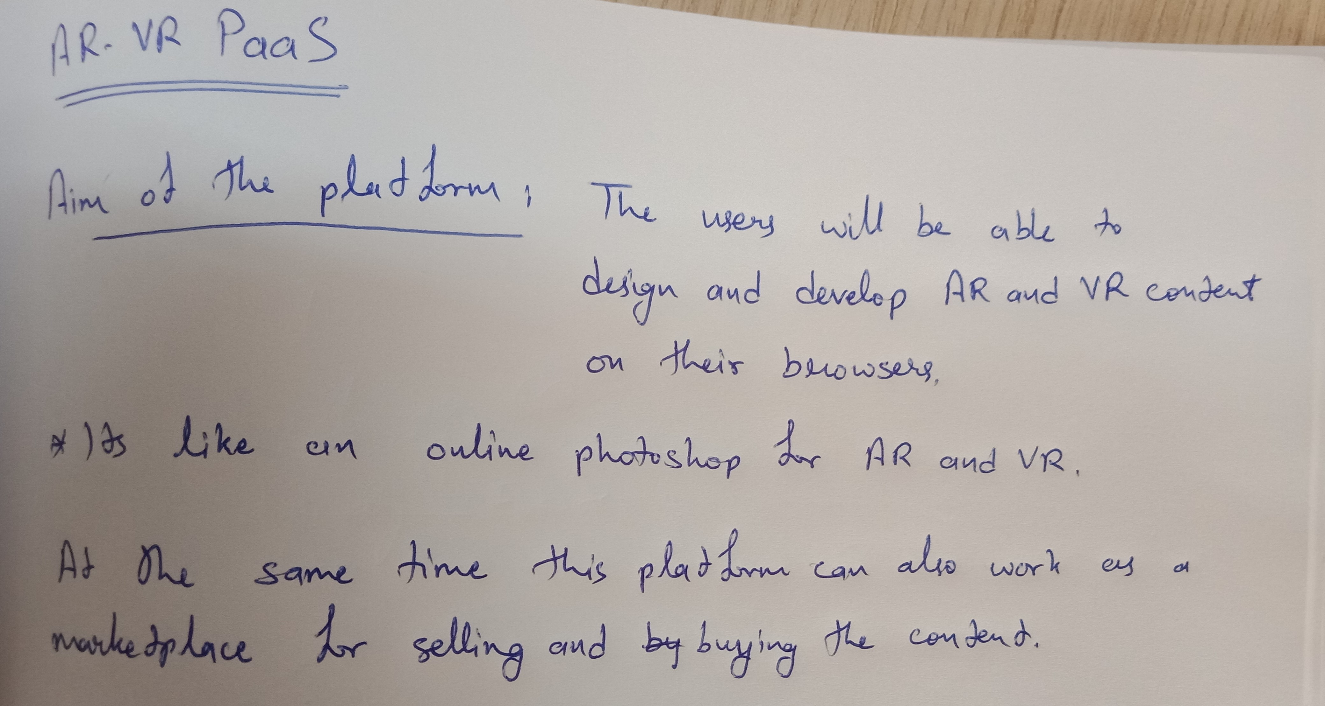

### 3.4 REQUIREMENTS

* Server Side

1. Cloud Infrastructure (High performance) -> Cloud infrastructure is made up of several components, each integrated with one another into a single architecture supporting business operations. For further details, refer section 3.1.
2. Internet connectivity (Low latency, high speed fiber optic/5G) -> it includes dial-up telephone lines, always-on broadband connections, and wireless devices. Among these, wireless access to the Internet is the newest. For working online on cloud servers, good internet connection becomes a necessity.
3. Website as a web platform (API also)

* User end

1. Computer with basic GPU-: Any PC with a basic GPU can be used to access our platform and reap its benefits. The strain on user hardware is kept to a minimum with the use of cloud computing.
2. Internet connectivity (high speed fiber optic/5G with low latency)-: The internet connectivity on both sides, user and us, shall be of low latency. This will engage in a smooth flow of work and will ensure the best experience on the user side.
3. VR headset (for VR content)-: A VR headset will be essential if people want to work and use VR services.
4. Smartphone Application (if used on smartphone)

**\*The necessary requirements and details regarding this project are still under process of evaluation. Basic requirements for both user and client side are mentioned above distinctly but are not the finalized version of such. The phase of data gathering and requirement analysis will be completed shortly and an updated version, of this section, will be made available as soon as possible.**

### 3.5 STATISTICAL ANALYSIS

The use of AR-VR is vastly growing in many industries. This statement might seem crude, but here are some statistics which show how the use of AR-VR is increasing day by day and also what are the major obstacles in popularising and in the universal acceptance of such revolutionary technology.

* **Statista** stated that, ‘the AR market was worth roughly $3.5 billion in 2017 and will reach a staggering $198 billion in 2025’. For VR **“Markets and Markets”** has predicted that, ‘the virtual reality market was worth $5.12 billion in 2017, and by 2023, the market will reach $34.08 billion. This means that VR market value will grow at a CAGR of 33.95% during the forecast period’.
* On the obstacles towards AR-VR technology, “Finances online” published these numbers:

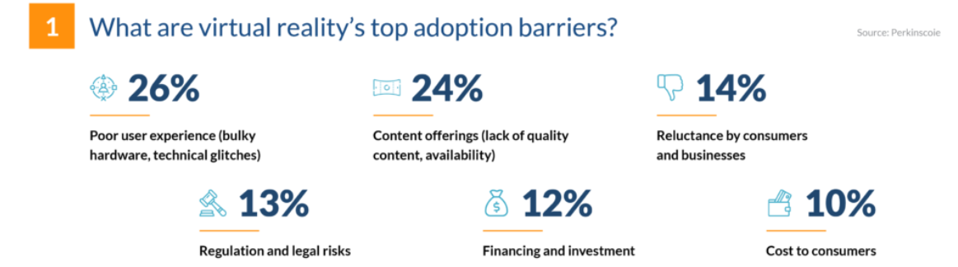

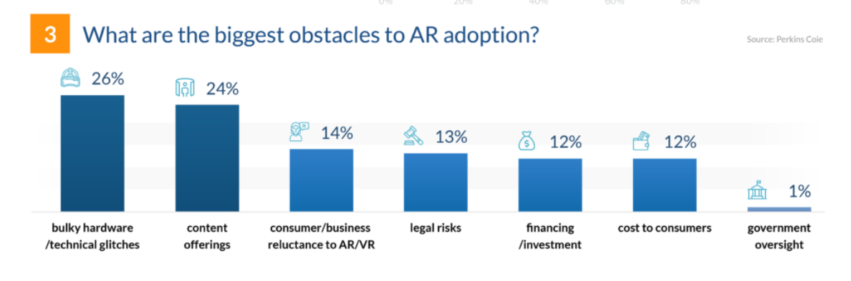

From the above chart it is quite clear that the high-end requirements of hardware is one of the major barrier in the use of AR-VR.

* Where technically oriented companies are utilizing its benefits, most part of the world still has to explore this area. Some statistics show that the adoption of AR technology in the world has grown to 37%.

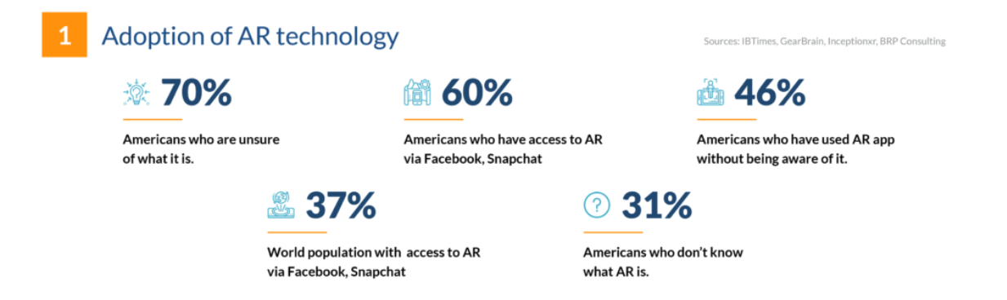

### 3.6 TARGET AUDIENCE

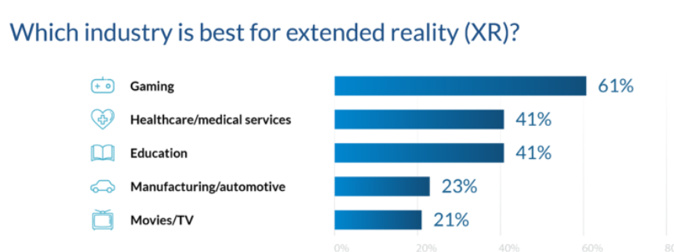

1. **Institutions/Organizations, using AR-VR for simulation:** Any institution can collaborate with us to provide this platform to the students as part of their course curriculum and projects. Organizations can use our platform to build an interactive environment to train their employees, the experience with AR-VR tech can minimize the use of resources applied and maximize the outcome in performance training. In sectors like police department, fire department, natural disasters and many like them. A virtual environment can be developed for the community, to practice, how to escape from these kinds of disasters.
2. **Game Developers:** They can use our platform for an interactive environment to develop and design a game. They can build completely immersive user experience for gamers.
3. **Engineers and Architects:** can use our platform to create models and design infrastructures with minimum resources and expenses.
4. **Data Analytics and Visualization:** It is easy to work and analyze data with a 3-D view than just on a sheet of paper. User can also develop an environment to visualize and analyze big data.

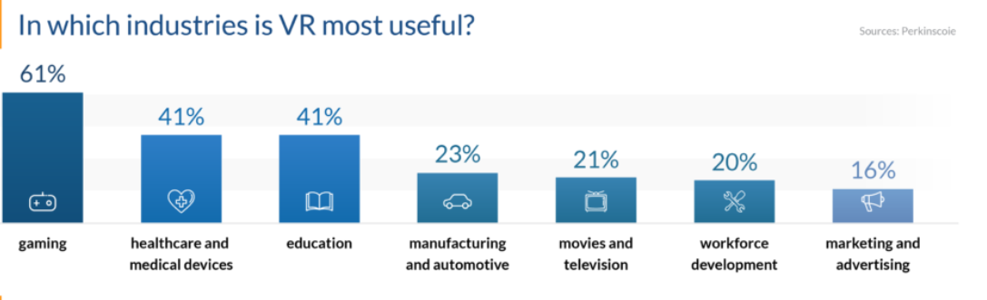

# 4. Data flow diagram (DFD)

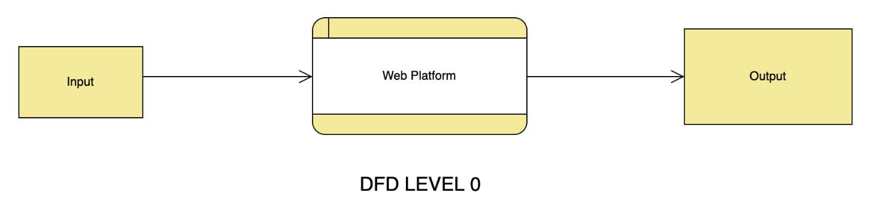

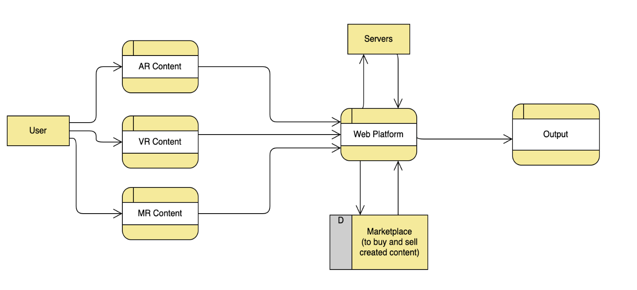

**DFD LEVEL 1**

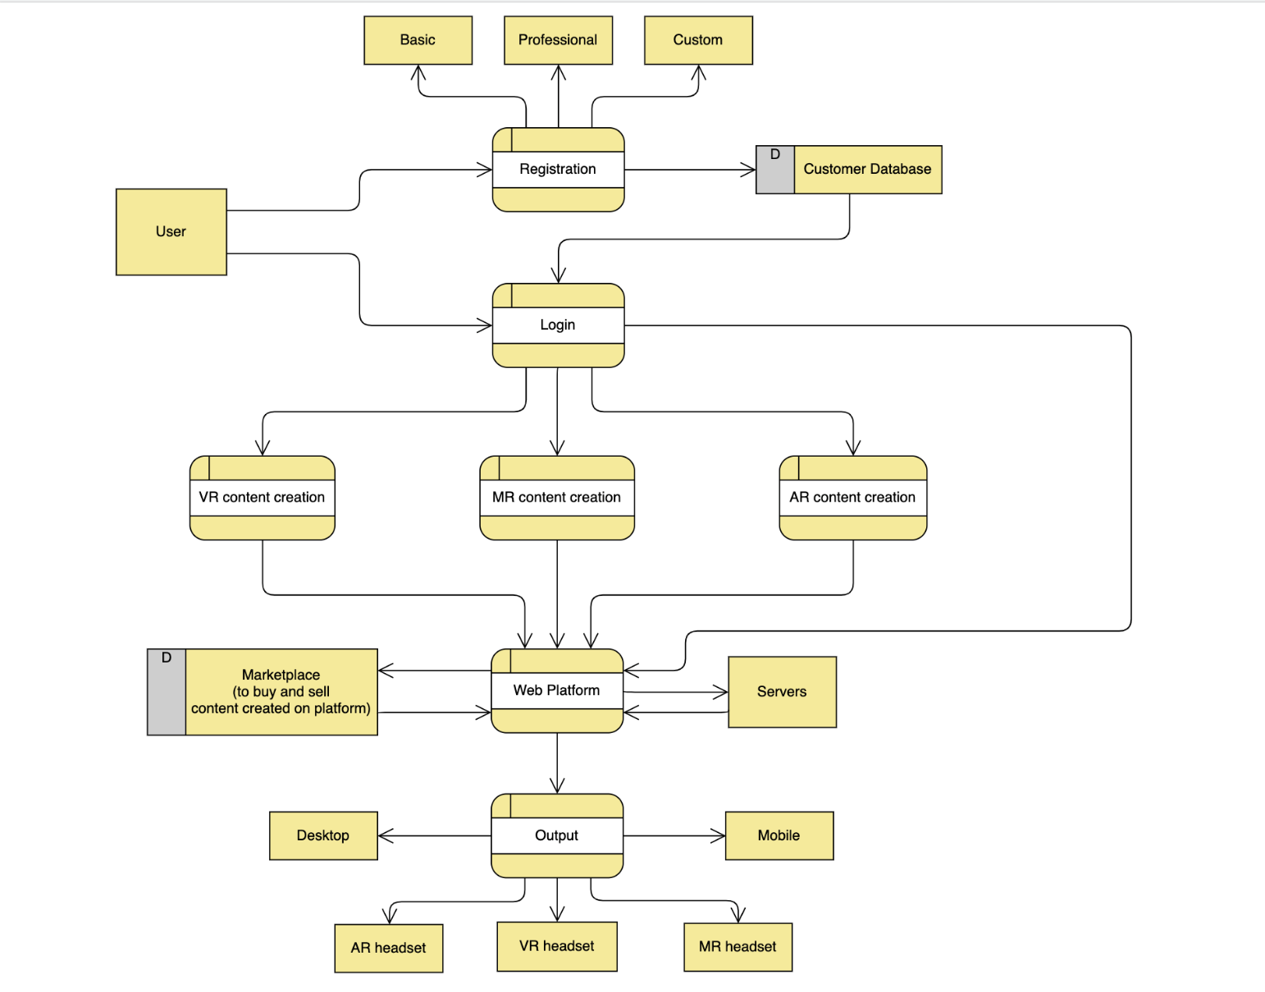

**DFD LEVEL 2**

# 5. Entity Relationship Diagram (ERD)

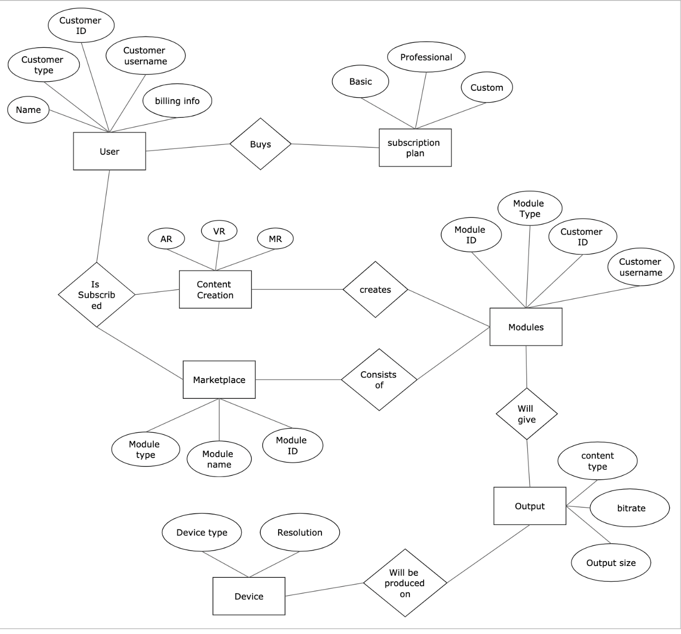

# 6. Program Evaluation and Review Technique

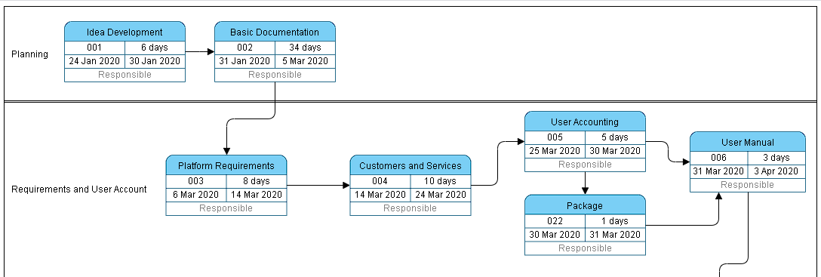

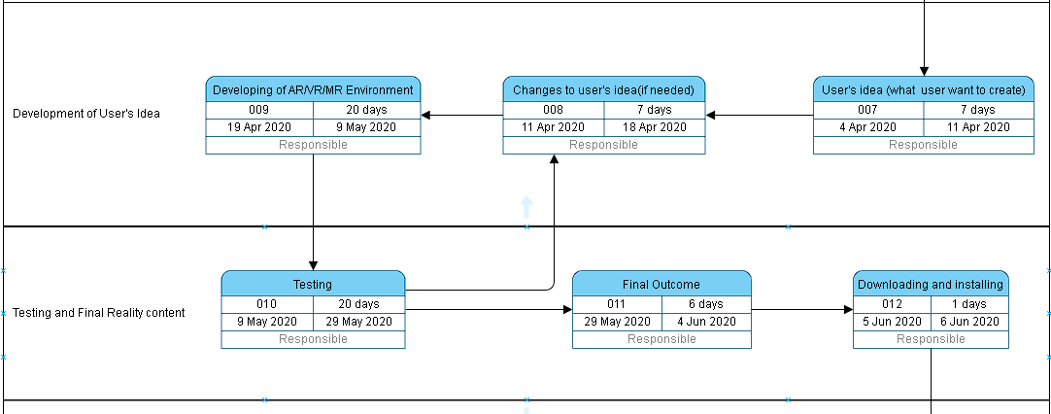

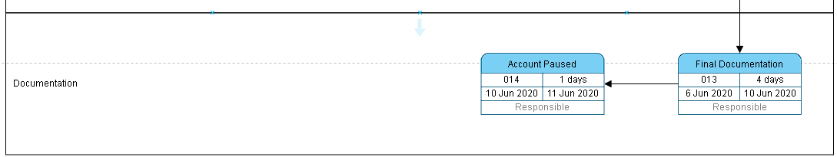

# 7. CONCLUSION

Reality is a tricky concept in todays world. With new technology and modern thinking, interaction with the virtual world has become majorly popular. Living in a Virtual environment or becoming an implicit part of the cyber space is no longer just a dream. With AR-VR technology growing so drastically in the past few decades new possibilities have surely emerged on our door steps. Although people are susceptible towards this tech, its use in our daily life is minimum due to its complexity and high-end demands on hardware. But that’s where we come in.

Our platform is a simple yet innovative way, which bringing people an opportunity to turn their dreams into reality. It deals in modern technologies like, cloud computing, AR, VR, etc. and at the same time brings that simplicity to the user, through which anyone with a pc and a viable internet connection turn their ideas into reality. It not only promotes creative thinking, but is also a medium to develop such. AR-VR technologies are the tool to build an advanced and bright future. Together with the use of cloud servers, we are creating something unique and extensive which will help people to step into the light of a better tomorrow.

# 8. REFRENCES

* N. Gilbert, "62 Virtual Reality Statistics You Must Know in 2020: Adoption, Usage & Market Share - Financesonline.com", *Financesonline.com*, 2020. [Online]. Available: https://financesonline.com/virtual-reality-statistics/. [Accessed: 17- Mar- 2020].
* N. Gilbert, "45 Vital Augmented Reality Statistics: 2020 Market Share & Data Analysis - Financesonline.com", *Financesonline.com*, 2020. [Online]. Available: https://financesonline.com/augmented-reality-statistics/. [Accessed: 17- Mar- 2020].
* A. Drogemuller, A. Cunningham, J. Walsh, B. Thomas, M. Cordeil and W. Ross, "Examining virtual reality navigation techniques for 3D network visualisations", *Journal of Computer Languages*, vol. 56, p. 100937, 2020. Available: 10.1016/j.cola.2019.100937.
* C. Kopp, "Learn About Program Evaluation Review Technique — PERT Charts", *Investopedia*, 2020. [Online]. Available: https://www.investopedia.com/terms/p/pert-chart.asp. [Accessed: 19- Mar- 2020].
* “Feature-driven development", *En.wikipedia.org*, 2020. [Online]. Available: https://en.wikipedia.org/wiki/Feature-driven_development. [Accessed: 17- Feb- 2020].
* L. Coyne, J. Takemoto, B. Parmentier, T. Merritt and R. Sharpton, "Exploring virtual reality as a platform for distance team-based learning", *Currents in Pharmacy Teaching and Learning*, vol. 10, no. 10, pp. 1384-1390, 2018. Available: 10.1016/j.cptl.2018.07.005 [Accessed 22 February 2020].
* “Cloud computing", *En.wikipedia.org*, 2020. [Online]. Available: https://en.wikipedia.org/wiki/Cloud_computing. [Accessed: 22- Feb- 2020].